SVN Tagging and Branching
To create a production copy of the MLib source-code we recommend that we tag and branch MLib to create snapshot of the library. Once done the production snapshot or branch is to remain unmodified so that we can replicate the production environment and reproduce any DLL's, XLL add-ins and other production files as needed.
In what follows we provide instructions on how to tag and branch MLib followed by a complete overview of branching and tagging in general. Note there are several ways to tag and branch and not all methods require a working copy of the repository to be checked-out.

Tagging & Branching MLib
Firstly open Windows Explorer and right-click on your MLib working copy. Next select TortoiseSVN->Branch/Tag as show below.
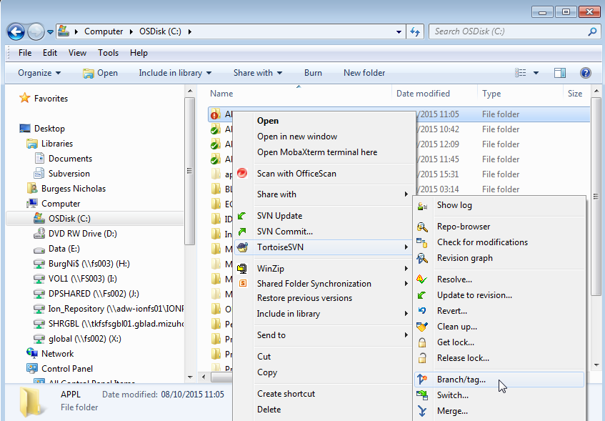
Secondly in the Branch/Tag screen that follows update the "To path:" as follows "/tags/<version-YYYY.MM.DD>".
Select a specific revision of the library or working copy for the production snapshot / branch as appropriate.
Finally click OK.
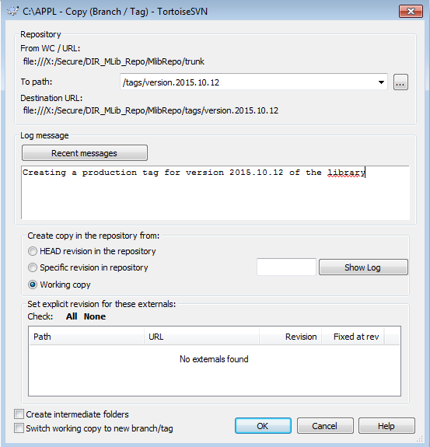

Switching the Working Copy to a Tag or Branch
Switching your working copy to a previous tag or branch is done from Windows Explorer by right-clicking on your MLib working copy and selecting Switch as shown below.
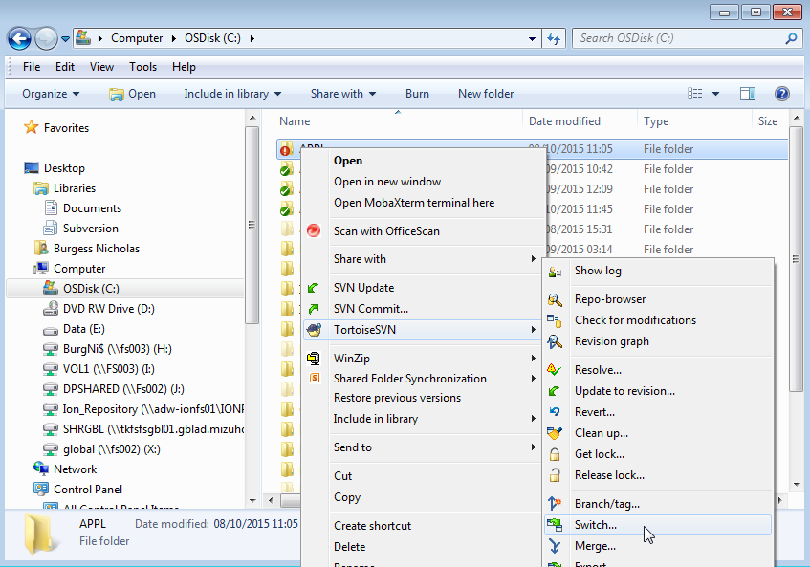
Next update the "To path:" as follows "/tags/<version-YYYY.MM.DD>", we usually need to tick Ignore Ancestry, see bottom left of the below screenshot, this is so that differences between the previous working copy folder structure and version numbers etc. are ignored.
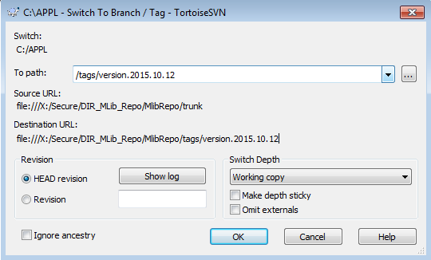

General Instructions for Branching & Tagging
One of the features of version control systems is the ability to isolate changes onto a separate line of development. This line is known as a branch. Branches are often used to try out new features without disturbing the main line of development with compiler errors and bugs. As soon as the new feature is stable enough then the development branch is merged back into the main branch (trunk).
Another feature of version control systems is the ability to mark particular revisions (e.g. a release version), so you can at any time recreate a certain build or environment. This process is known as tagging.
Subversion does not have special commands for branching or tagging, but uses so-called “cheap copies” instead. Cheap copies are similar to hard links in Unix, which means that instead of making a complete copy in the repository, an internal link is created, pointing to a specific tree/revision. As a result branches and tags are very quick to create, and take up almost no extra space in the repository.

Creating a Branch or Tag
If you have imported your project with the recommended directory structure, creating a branch or tag version is very simple:

Figure 4.52. The Branch/Tag Dialog
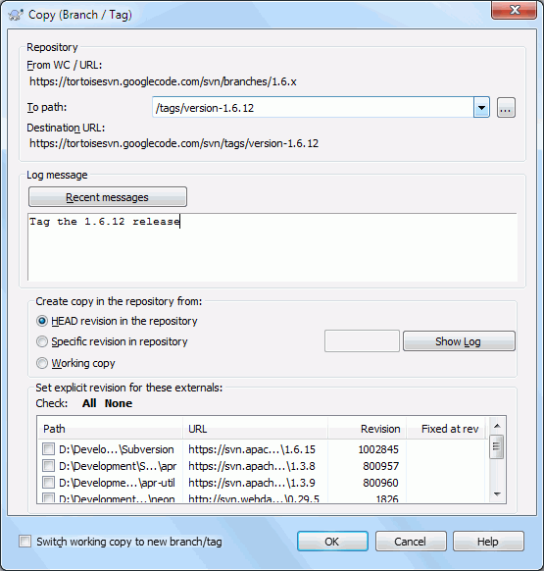
Select the folder in your working copy which you want to copy to a branch or tag, then select the command TortoiseSVN →Branch/Tag....
The default destination URL for the new branch will be the source URL on which your working copy is based. You will need to edit that URL to the new path for your branch/tag. So instead of
http://svn.collab.net/repos/ProjectName/trunk

you might now use something like
http://svn.collab.net/repos/ProjectName/tags/Release_1.10

If you can't remember the naming convention you used last time, click the button on the right to open the repository browser so you can view the existing repository structure.

intermediate folders
When you specify the target URL, all the folders up to the last one must already exist or you will get an error message. In the above example, the URL http://svn.collab.net/repos/ProjectName/tags/ must exist to create the Release_1.10 tag.
However if you want to create a branch/tag to an URL that has intermediate folders that don't exist yet you can check the option Create intermediate folders at the bottom of the dialog. If that option is activated, all intermediate folders are automatically created.
Note that this option is disabled by default to avoid typos. For example, if you typed the target URL as http://svn.collab.net/repos/ProjectName/Tags/Release_1.10 instead ofhttp://svn.collab.net/repos/ProjectName/tags/Release_1.10, you would get an error with the option disabled, but with the option enabled a folder Tags would be automatically created, and you would end up with a folder Tags and a folder tags.
Now you have to select the source of the copy. Here you have three options:
HEAD revision in the repository. The new branch is copied directly in the repository from the HEAD revision. No data needs to be transferred from your working copy, and the branch is created very quickly.S pecific revision in the repository. The new branch is copied directly in the repository but you can choose an older revision. This is useful if you forgot to make a tag when you released your project last week. If you can't remember the revision number, click the button on the right to show the revision log, and select the revision number from there. Again no data is transferred from your working copy, and the branch is created very quickly. Working copy The new branch is an identical copy of your local working copy. If you have updated some files to an older revision in your WC, or if you have made local changes, that is exactly what goes into the copy. Naturally this sort of complex tag may involve transferring data from your WC back to the repository if it does not exist there already.

If you want your working copy to be switched to the newly created branch automatically, use the Switch working copy to new branch/tag checkbox. But if you do that, first make sure that your working copy does not contain modifications. If it does, those changes will be merged into the branch WC when you switch.
If your working copy has other projects included with svn:externals properties, those externals will be listed at the bottom of the branch/tag dialog. For each external, the target path and the source URL is shown.
If you want to make sure that the new tag always is in a consistent state, check all the externals to have their revisions pinned. If you don't check the externals and those externals point to a HEAD revision which might change in the future, checking out the new tag will check out that HEAD revision of the external and your tag might not compile anymore. So it's always a good idea to set the externals to an explicit revision when creating a tag.
The externals are automatically pinned to either the current HEAD revision or the working copy BASE revision, depending on the source of the branch/tag:

Table 4.1. Pinned Revision

Copy Source | Pinned Revision
HEAD revision in the repository | external's repos HEAD revision
Specific revision in repository | external's repos HEAD revision
Working copy | external's WC BASE revision

externals within externals
If a project that is included as an external has itself included externals, then those will not be tagged! Only externals that are direct children can be tagged.
Press OK to commit the new copy to the repository. Don't forget to supply a log message. Note that the copy is createdinside the repository.
Note that unless you opted to switch your working copy to the newly created branch, creating a Branch or Tag does not affect your working copy. Even if you create the branch from your WC, those changes are committed to the new branch, not to the trunk, so your WC may still be marked as modified with respect to the trunk.

Other ways to create a branch or tag
You can also create a branch or tag without having a working copy. To do that, open the repository browser. You can there drag folders to a new location. You have to hold down the Ctrl key while you drag to create a copy, otherwise the folder gets moved, not copied.
You can also drag a folder with the right mouse button. Once you release the mouse button you can choose from the context menu whether you want the folder to be moved or copied. Of course to create a branch or tag you must copy the folder, not move it.
Yet another way is from the log dialog. You can show the log dialog for e.g. trunk, select a revision (either the HEAD revision at the very top or an earlier revision), right click and choose create branch/tag from revision....

To Checkout or to Switch...
...that is (not really) the question. While a checkout downloads everything from the desired branch in the repository to your working directory, TortoiseSVN → Switch... only transfers the changed data to your working copy. Good for the network load, good for your patience. :-)
To be able to work with your freshly generated branch or tag you have several ways to handle it. You can:
- TortoiseSVN → Checkout to make a fresh checkout in an empty folder. You can check out to any location on your local disk and you can create as many working copies from your repository as you like.
- Switch your current working copy to the newly created copy in the repository. Again select the top level folder of your project and use TortoiseSVN → Switch... from the context menu.
In the next dialog enter the URL of the branch you just created. Select the Head Revision radio button and click on OK. Your working copy is switched to the new branch/tag.
Switch works just like Update in that it never discards your local changes. Any changes you have made to your working copy which have not yet been committed will be merged when you do the Switch. If you do not want this to happen then you must either commit the changes before switching, or revert your working copy to an already-committed revision (typically HEAD).
- If you want to work on trunk and branch, but don't want the expense of a fresh checkout, you can use Windows Explorer to make a copy of your trunk checkout in another folder, then TortoiseSVN →Switch... that copy to your new branch.

Figure 4.53. The Switch Dialog
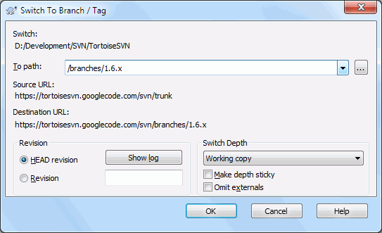

Although Subversion itself makes no distinction between tags and branches, the way they are typically used differs a bit.
- Tags are typically used to create a static snapshot of the project at a particular stage. As such they are not normally used for development - that's what branches are for, which is the reason we recommended the /trunk /branches /tags repository structure in the first place. Working on a tag revision is not a good idea, but because your local files are not write protected there is nothing to stop you doing this by mistake. However, if you try to commit to a path in the repository which contains /tags/, TortoiseSVN will warn you.
- It may be that you need to make further changes to a release which you have already tagged. The correct way to handle this is to create a new branch from the tag first and commit the branch. Do your Changes on this branch and then create a new tag from this new branch, e.g. Version_1.0.1.
- If you modify a working copy created from a branch and commit, then all changes go to the new branch and not the trunk. Only the modifications are stored. The rest remains a cheap copy.

